Press release

**Contract cleaning – from coarse cleaning to high-purity applications**

**Defined clean surfaces as a service from the plant manufacturer**

**From coarse cleaning to intermediate and precision cleaning to ultra-fine and high-purity cleaning – the needs-based, economical, and sustainable cleaning of workpieces and assemblies requires not only optimally adapted cleaning technology but also the appropriate cleaning expertise. In its three test and service centers in Germany, which specialize in different cleaning tasks and cleanliness categories, Ecoclean not only enables the needs-based design of cleaning processes, but also provides contract cleaning services for components made of a wide variety of materials.**

Whether high productivity, the quality of subsequent processes, a long product life, or improved competitiveness, component cleaning influences each of these points as an essential manufacturing step. Cleanliness requirements vary greatly depending on the industry, workpiece, production phase, and area of application. To meet these very different cleanliness requirements, Ecoclean has been operating three test and service centers in Germany for many years. They specialize in different cleaning applications and have state-of-the-art equipment, process, and drying technologies for water-based and solvent cleaning, as well as connected laboratories for cleanliness testing, compatibility testing, and quality determination of cleaning media. In addition to meaningful tests for the design and optimization of plant technology and processes under production-like conditions, this equipment also enables the provision of customized cleaning services for components made of almost all materials.

**Customized contract cleaning in three categories**

The spectrum ranges from classic partial cleaning to fine and precision cleaning to ultra-fine and high-purity cleaning. In addition, high-pressure deburring and decoating are also offered as services.

In the area of classic cleaning, known as category "A," the components are predominantly those that are manufactured in large quantities in general industry, by automotive suppliers, and in other sectors, and for which there are no strict cleanliness requirements to be met, such as being "free of particles and grease" on the surface. Cleanliness is checked visually and using conventional measurement methods.

Category "B," fine and precision cleaning, covers parts and components made of various materials and used in different industries, such as automotive, aviation, sensor, electronics, and coating industries, as well as medical technology. Defined specifications regarding particulate and filmic cleanliness must be met, which is why these parts have usually already undergone pre-cleaning. Typical applications in this area include the cleaning of housings, optical components, implants, and medical instruments, as well as parts such as bipolar plates prior to coating. Microscopes, particle scanners, systems for measuring surface tension, endoscopes, and a mobile cleanroom cabin are available for checking for residual particulate and film contamination, for example, in accordance with VDA 19 or factory standards. If validation of cleaning processes is required, for example in medical technology, the range of services includes the appropriate support, e.g., through pre-validation.

Tasks in ultra-fine and high-purity cleaning (category C), which place extremely high demands on particulate, filmic, and organic cleanliness and require the avoidance of so-called "harmful" elements (hydrogen-induced outgassing = HIO substances), are carried out in a validated class 7 cleanroom with ISO 6 zones. Integrated treatment solutions for reverse osmosis (RO), deionized (DI), and ultra-pure water (UPW) enable the use of all water qualities used in ultra-fine and high-purity cleaning. Typical applications include the cleaning of components from laser, measurement, analysis, vacuum technology, aerospace, and precision optics, as well as components for semiconductor production equipment. Various measurement and analysis methods, including customer-specific ones (e.g., microscopy, residual gas analysis, UV light, and fluorescence measurement), as well as a packaging station for cleaned parts, ensure that the high cleanliness requirements are met.

**Contract cleaning – the solution in many cases**

There are many reasons for outsourcing cleaning services. It starts with capacity bottlenecks in the company's own cleaning department or the fact that investing in an appropriate cleaning system does not yet pay off for a new series part due to the quantities involved. Increased cleanliness requirements mean that new processes have to be developed. Certain parts have to meet higher cleanliness specifications than the rest of the product range. There is a lack of trained personnel to ensure compliance with very high cleanliness specifications.

Contact: Ecoclean GmbH, Rainer Straub, 70794 Filderstadt, Germany,

Phone +49 711 7006-0, contractcleaning.filderstadt@ecoclean-group.net,

www. ecoclean-group.net

Image captions

Photo: Ecoclean_PR_Contract Cleaning_1

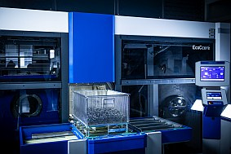

Depending on the task at hand, contract cleaning is carried out in one of three specialized testing and service centers.

Photo: Ecoclean_PR_Contract Cleaning_Cleaning categories

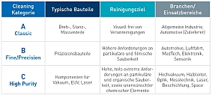

The range of contract cleaning services extends from classic cleaning to fine and precision cleaning to ultra-fine and high-purity cleaning.

Photo: Ecoclean_PR_Contract Cleaning_3P

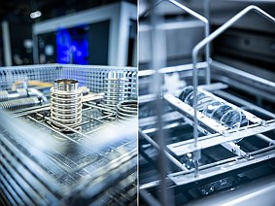

Bottlenecks in cleaning capacity, insufficient parts volume, workpieces with higher cleanliness requirements—there are many reasons to use component cleaning as a service.

Photo: Ecoclean_PR__Contract Cleaning_4

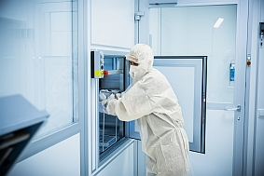

Contract cleaning is also an ideal solution for new parts with very high cleanliness requirements, as companies often do not want to invest immediately in the necessary equipment, such as plant technology and clean rooms, and lack appropriately trained personnel.

Image source: Ecoclean GmbH

*The SBS Ecoclean Group develops, produces, and markets forward-looking machinery, systems and services for industrial parts cleaning and surface processing, as well as customized automation solutions. Another area of activity is the development and series production of efficient alkaline electrolysis systems for the decentralized production of green hydrogen. Innovation is driven by the two competence centers in Germany, which support the global Group companies with technical expertise, research, and pioneering developments. The world's leading parts cleaning solutions help companies around the globe in a wide range of industries, such as mechanical engineering, the semiconductor supply industry, precision optics, medical technology, the automotive industry, and its suppliers, microtechnology and precision engineering, aerospace, cutting tools, and fasteners, to produce efficiently and sustainably at high quality levels. Ecoclean's success is based on innovation, cutting-edge technology, sustainability, being close to our customers, diversity, and respect. The Group of companies unites the Ecoclean, UCM and Mhitraa brands. It has twelve locations in Germany and eight other countries worldwide and employs a workforce of around 900.*

- - -

Thank you in advance for sending us a copy or a link to the publication.

**Contact for editorial offices**SCHULZ. PRESSE. TEXT., Doris Schulz, Journalist DJV  
Landhausstrasse 12, 70825 Korntal, Germany, Phone +49 711 854085,   
[ds@pressetextschulz.de](mailto:ds@pressetextschulz.de), [www.schulzpressetext.de](http://www.schulzpressetext.de)

Ecoclean GmbH, Kathrin Gross, Marketing  
Phone +49 711 7006-223, Fax +49 711 7006-148  
[kathrin.gross@ecoclean-group.net](mailto:kathrin.gross@ecoclean-group.net), [www.ecoclean-group.net](http://www.ecoclean-group.net)